For the 3rd year, an international workshop was organized by the Faculty of Medicine (Girls), Al-Azhar University in partnership with IFCC Working group on Flow cytometry. The workshop was under the patronage of Prof. Dr. **Mahmoud Seddik**, Vice President of Al-Azhar Univ. for Post-Graduate Studies and Research, Prof**. Dr. Hanaa El Ebeisy,** Dean of Faculty of Medicine, Prof. Dr. **Sawsan Abdelsabour**, Deputy of Faculty of Medicine Postgraduate and Research affairs, Prof. Dr. **Eman Elshal**, Deputy for Education and Student Affairs and Prof. Dr. **Amal Abdelaleem,** Head of Clinical Path. Dept., Al-Azhar Univ. who attended the opening ceremony of the workshop.

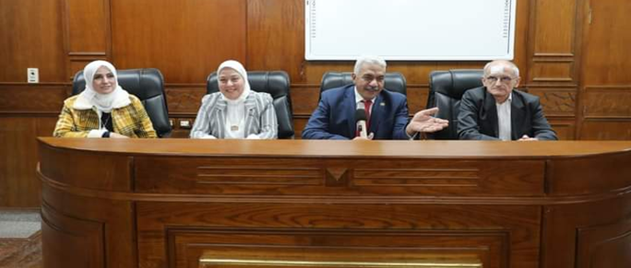

During the opening ceremony Prof. Dr. **Mahmoud Seddik**, presented Al-Azhar Univ. Shield of honor to **Dr. Claude Lambert** (MD, PhD) (Saint-Etienne Univ. Hospital, IFCC, France) in appreciation for his sharing of the IFCC experience and his continued efforts in the technical training process at Al-Azhar University.

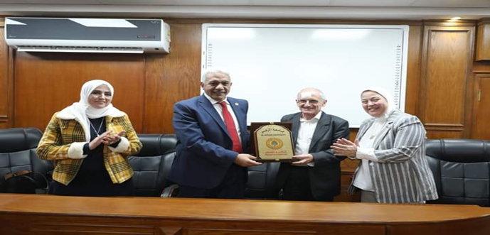

The workshop was coordinated by Ass. **Prof. Reham Hammad**, Head of Hematology Unit, Clinical Pathology Department, Faculty of Medicine (Girls), Al-Azhar University

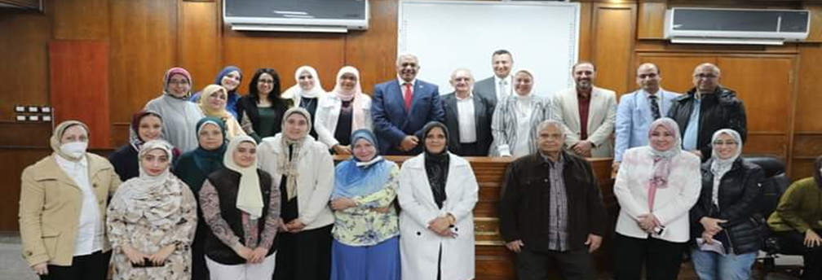

The workshop gathered 38 biologists from faculties of Medicine, Science and Pharmacy, coming from Al-Azhar, Assiut, Suez, Al-Mansoura, Benha, Ain-Shams, Alexandria, Cario and Tanta Universities from different parts of Egypt. In addition to doctors from Sudan and king Fahd Hospital from Saudi Arabia. Most people had experience in diagnosis and had access to the instruments but were mainly beginners.

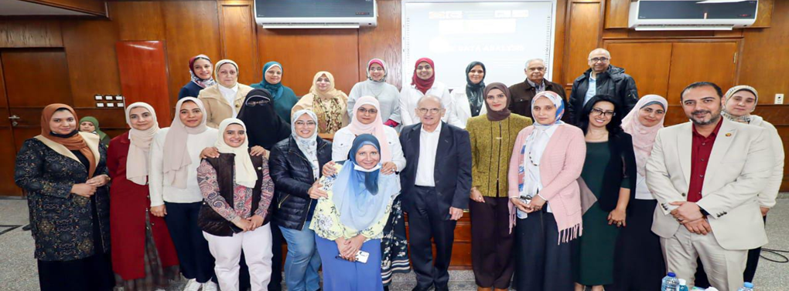

The lectures were performed during 2 days and a half, by experienced teachers form IFCC, Reham Hammad, Alshaymaa Alhabibi, Doaa Aly and Samar Mohammed from Al-Azhar Univ.; Mahmoud Hammad, Eman Kandil and Randa Osman from the National Cancer Institute and Abdel-Aziz Zidan from Damanhur Univ. They addressed technical bases and few diagnosis applications in T cell quantification, cell cycle and first steps in hematological disorder screening.

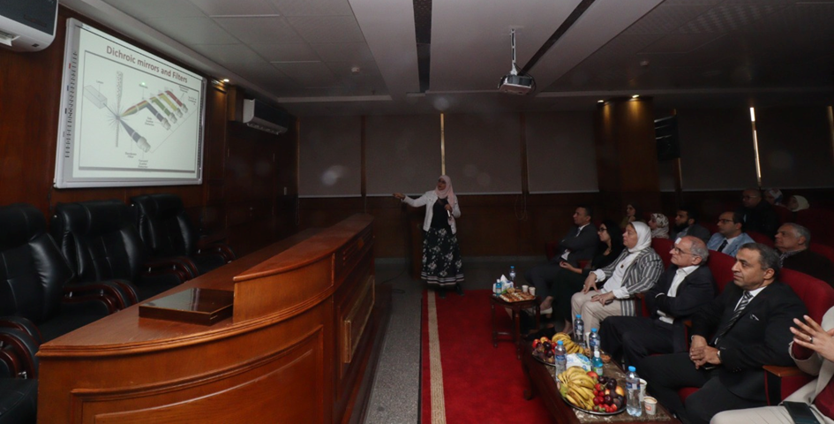

The last half a day participants performed some practical exercises on the Kaluza software and performed sample preparation, acquisition on an instrument and data analysis, with the help of Mr. Ibrahim Ali, the Flow cytometry Lab. Technician.

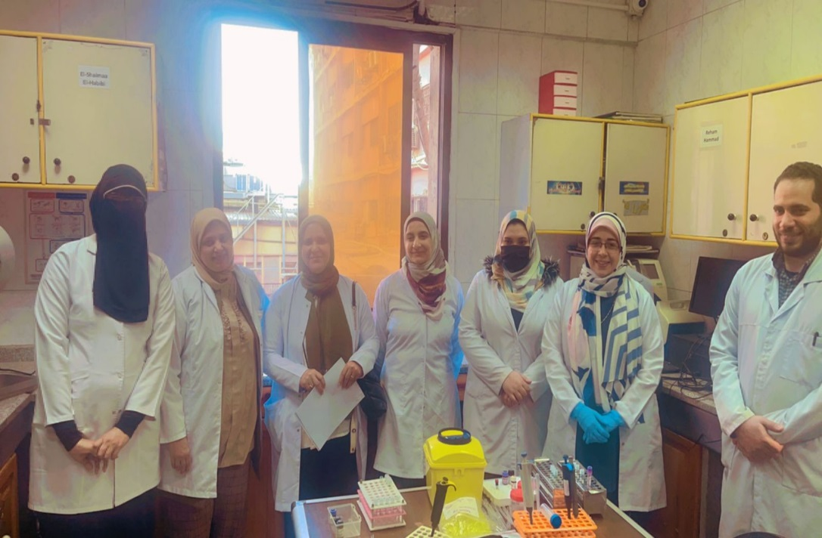

Lecture material and data for training were shared for participants to train. General ambiance was very friendly. Participant were very enthusiast and lots of questions and discussion animated the lectures. It was also a rare occasion for people to meet and network. Certificate were distributed by the end of the workshop to the participants. According to early feedback, the workshop was considered as very informative and many ask for a new session next year. The need for an advanced session was also reported.

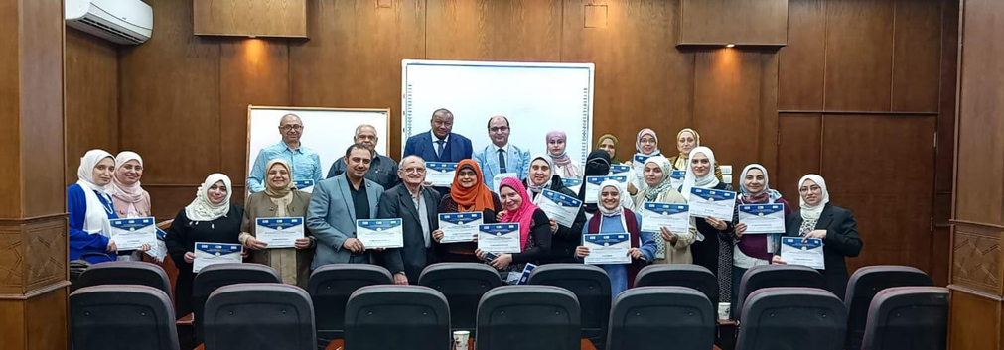

This is the only annual activity on education and training in the field on cell analysis, in immunology or hematology in Egypt until now. This explain the great success, in Egypt and even in surrounding countries. This encourage us to renew the experience next year and we plan to extend it in order to promote advance applications and networking of experienced cytometrists in the region to cross talk and exchange growing up expertise and know-how.

